**EXPERIMENT 9**

**VIEWS**

**Aim:**

• Create table student with attributes id, name and department.

• Display

• Create view and select

• Insert values

• Create view with check option

• Insert values and alter table.

**Code:**

**create table view_student(studno int,stu_name varchar(20),dept varchar(20));**

**insert into view_student values(1,"Ravi","CSE"),(2,"Jyothika","ECE"),(3,"Deekshita","IT"),(4,"Sathvika","EEE");**

**select *from view_student;**

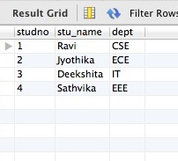

create view v_stud as select * from view_student;

select * from v_stud;

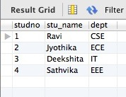

insert into v_stud values(6,"Sreeja","CSE");

select * from v_stud;

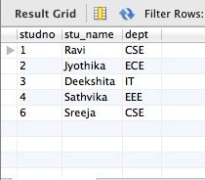

#check point

create view v_stud2 as select * from view_student with check option;

insert into v_stud2 values(7,"Pranathi","IT");

select * from v_stud2;

;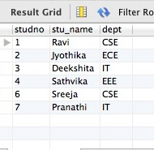

alter view v_stud2 as select studno,stu_name from view_student where studno-3;

select * from v_stud2;

